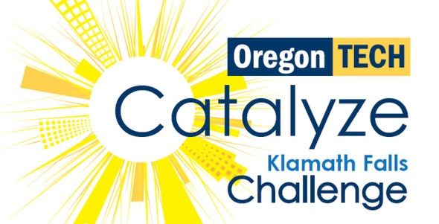
Catalyze Klamath Falls Challenge VIII: 2023
Official Rules and Information (2022-2023)
Purpose: Create and reward a culture of innovation, entrepreneurship, and business formation in Klamath Falls to ignite rural economic development and provide relevant student project experiences.

Theme of the Challenge
- “Innovation Close to Home”: challenging students to consider how a new idea, product, or service can add value and meaning in everyday lives and could become a thriving business in the Klamath Basin
- This broad theme allows for a wide variety of interpretation and flexibility in the development of new ideas
- Participants should consider how a concept, prototype, or service might address a ‘user- centered’ problem that the project team identifies through their early research, and that could be designed, manufactured, or remotely delivered from Klamath Falls
- The challenge involves both innovation to solve a problem and innovation in the business model, resulting in potential job growth in rural Oregon

Scope of the Challenge
- Develop a start-up concept or prototype for a new product or service
- The start-up concept or prototype needs to meet a user/customer need and have a substantial potential market
- The concept or prototype can be designed so that it can be developed or manufactured in Klamath County, or if it is a service, it can be delivered electronically or remotely from a Klamath location
- The concept should be ‘new’ or ‘uniquely different’ from products that are currently on the market
- All types of business ideas are welcome, and the judges will be looking for business ideas that have impact, solve real problems, are attractive to investors, and have the potential to create jobs in the region

Team Composition & Registration
- Teams may be composed of two or more registered Oregon Tech undergraduate or graduate students or recent Oregon Tech or KCC alumni who graduated in the past four years (2019-2022 graduates)
- Any major or field of study or location is welcome to participate
- Interdisciplinary teams are highly recommended
- All work must be performed by student or recent alumni team members. Teams are encouraged to solicit business or product development expertise in an advisory fashion, but are prohibited from utilizing any outside paid professional or financial consultants. Faculty advisors are welcome and encouraged to mentor teams, but are not allowed to write the team reports or participate in the team presentation.
- Winners of previous Catalyze Challenge contests are not eligible to compete with the same winning concept or product
- All teams must be registered by 5:00 PM PST on January 23, 2023

Competition
- Team projects will be judged by a panel of experts using the Catalyze Klamath Scoring Guide
- Judges will also select up to two teams to participate in the InventOR competition based on overall Catalyze Klamath score and InventOR eligibility
- Winning teams will be awarded prizes, for the team to share or to use for start-up costs and further project development

Preliminary Concept Submissions & Shark Tech
- All teams must submit a Preliminary Concept Form by February 13, 2023 and compete in the Shark Tech pitch contest
- Failure to submit these materials and/or compete may forfeit the team’s chances of presenting in the final event
- Depending on the number of teams entered in the challenge, the preliminary concept submission and Shark Tech Pitch Contest may be used as an elimination round for the final event

Final Judged Presentations
- Final Reports are due on April 10, 2023 by 5pm to Hallie Neupert
- Failure to submit this report will forfeit the team’s chances of presenting in the final event

Tentative Timeline
(Note that some dates are tentative. Additional non-mandatory events may be scheduled)
- November 2, 2023: Catalyze Klamath Challenge VII Kick-Off Meeting - This is a hosted event for students, faculty, and community members to learn about the contest and begin to form teams
- January 18, 2023: Pre-Registration Team Formation - This is a hosted event for all prospective contestants to meet and network with potential team members as well as register for the event
- January 23, 2023: Catalyze Team Registration is due at 5:00pm
- February 8, 2023: Catalyze Team Meet and Greet - This is a hosted event for all teams to meet with the Catalyze Klamath mentor network and learn about available external resources
- February 13, 2023: Preliminary Concept Submission is due at 5:00pm
- March 1, 2023: Annual SharkTech Venture Pitch Contest & Selection of finalists to compete (if needed) - (Tentative Date) Mandatory for all teams.
- April 10, 2023: Final Report is due at 5:00pm
- April 20, 2023: Catalyze Klamath Falls Challenge Contest - Teams will compete in front of a panel of judges for the PRIZES! A list of judges, prizes and final details will be posted prior to the competition

Team and Mentor Meetings
- Team & Mentor Meetings will be held throughout the competition to assist teams.
- Attendance is not required, but it is highly encouraged as these will be the main forum for questions and announcements throughout the competition.
- Teams are highly encouraged to consult with their faculty mentors regularly, and to seek complementary expertise and advice from community members.
More Information
For more information, contact Hallie Neupert at hallie.neupert@oit.edu or visit the Catalyze website at www.oit.edu/catalyze.

