Faculty - Alternative Testing Agreement
- When you receive the Faculty Notification Letter (FNL) email, please locate and click “Alternative Testing Agreement.”
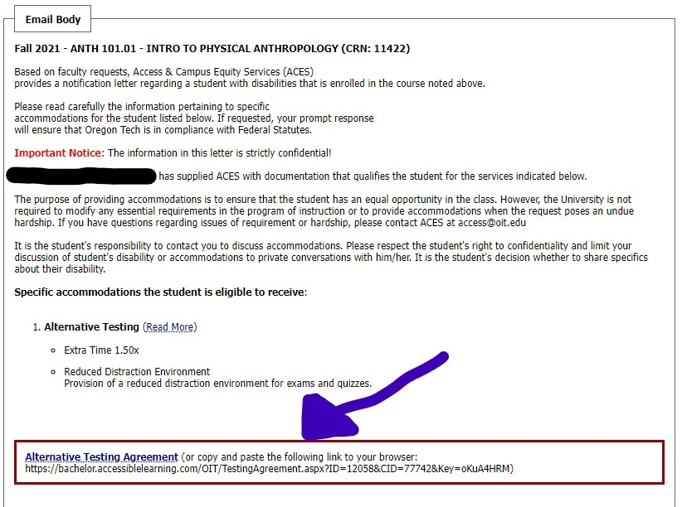

- Please read over the Testing Agreement and fill out the boxes at the bottom, with information regarding your exam times. Please input the time that all students will be given in your course, as AIM will automatically determine how much extra time to provide to students.
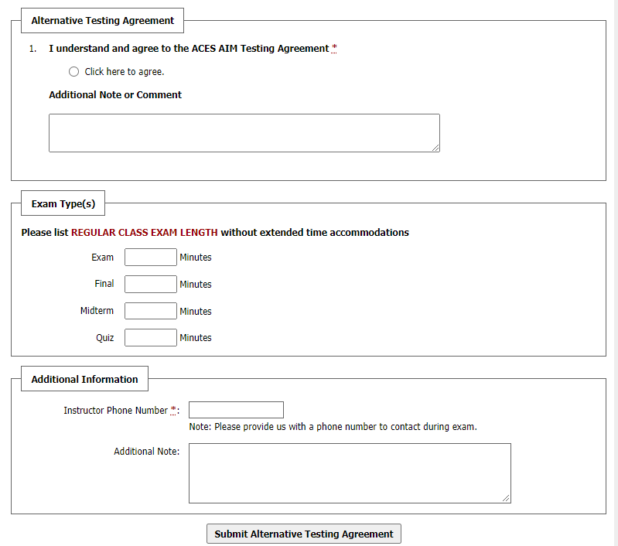
Note: Faculty should indicate in the “Additional Note” section any requirements or conditions for their exams. For example: students are not allowed to use calculator, please allow scratch paper, only basic calculator allowed, etc.

