Date: 1/19/24 Time:9am

Attendees: Christy VanRooyen, Cristina Crespo, Jennifer Wilson, Rachelle Barrett, Andie Fultz, David Johnston, Cecily Heiner, Don McDonnell

Items:

1. Associate Vice Provost Search: First candidate was on campus 1/17. Next two AVP candidates scheduled to be on campus 1/30 and 2/5. Using the same questions already developed (will be emailed separately). Attendance at the interview and the forum is a good idea to get an idea of the vision of this individual. Provide feedback via survey sent from Dierdre Harlan.
2. Program Reports. All peer reviews have been assigned. Bachelor’s programs will be peer reviewing Bachelor’s programs. Masters assigned to peer review masters program. Peer review canvas shell looks like this. 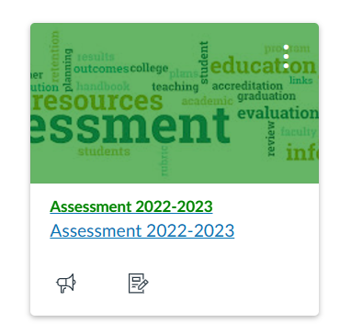
   1. Manufacturing and Communications departments are not participating this year. Email communications confirmed that they do not have the support or staffing to complete this task this year. Deans have been informed. Will be documented in our end of year report. Evidence (emails) will be saved in the Teams drive.
   2. Date/location of Peer Review training session: Feb 1st in Boivin Hall 2pm and on Teams. Christy will be in Boivin, Gary on Teams.
      1. Peer review assignment is being created using Don’s department’s report and group grading.
      2. Announcement will be sent through the canvas shell. All are welcome. An email to chairs and program coordinators will be sent by Rachelle.
3. Events:
   1. Program coordinator training event “getting ready for next year” for program coordinators need scheduled for spring term. This team will work on the training collaboratively.
   2. Canvas Tools Training for program coordinators to be spearheaded by CCT. Cecily, David Johnston, or Rachel Hanan to discuss with CCT.
4. Post-Graduation success data necessary for accreditation not being collected as it was. Should this committee pursue this? Intent to graduate data is being collected by senior exit survey (this committee) but 6 month data should be collected by career services. Discussion on if the source of data currently being published on program websites. Rachelle to discuss with Ken Fincher and new Career Services Director. Students may be more responsive if 6-month survey is sent by chairs, however chairs need to remain in the loop. Not our duty, but we should make request that it be done.
5. ISLO Committee Check In
   1. ETC committee currently updating Rubrics with intent to put into Canvas for use. Found inconsistent use of ISLO vs ESLO. Some are too wordy. Inconsistent grading of Proficient vs Foundational. Clarification that Proficiency Level should be rating of student performance on outcome. F/P/C means the delivery of materials in course.
      1. Warning from GEAC that definitions of ISLO outcomes may come from HECC requiring more updates so not to put too much work into language, however we cannot remain stagnant so change items that improve efficiency and standardization can still be made.
   2. Diverse Perspectives has a report from previous committee of goals. Gather more data on student perspective of DEI coursework, integrate DEI concepts into more courses, recruit more international students.
      1. DP committee will be looking at what was reported in program reports this term for other items.
   3. QLIA committee completed rubric integrations into Canvas. Ready for collection this year.
6. General Education. Good idea to bring ISLO rubrics to GEAC for approval. GEAC looking to set standards for qualification of courses as Gen Ed. Will be dependent on outcomes defined by HECC and definition of Foundation Level course work.
   1. Can’t move forward without AVP in place and HECC standards published.
   2. Should be thinking of how assessment plays a role in supporting General Education reform. Applicable standard: “Consistent with its mission, the institution establishes and assesses, **across all** associate and bachelor level **programs** or **within a General Education curriculum**, institutional learning outcomes and/or core competencies. Examples of such learning outcomes and competencies include, but are not limited to, effective communication skills, global awareness, cultural sensitivity, scientific and quantitative reasoning, critical analysis and logical thinking, problem solving, and/or information literacy.”
   3. Definition of Foundational/Practice/Capstone from our program report template: “**Foundation** (Introduction), **Practice** (Reinforcement and Application) and **Capstone** (Synthesis) levels.”
   4. Language from Biological Health Sciences 2022-23 report:

Discussion to be continued.