Assessment Agenda 5/22/24
Attendees: Don McDonnell, Krista Beaty, Christy VanRooyen, Rachelle Barrett, Rachel Hanan, Carrie Dickson, David Hammond, Cristina Crespo
- Provost’s meeting on 5/20/24 – Christy
  - Dr. Afjeh confirmed that this Committee may make changes to which outcomes are assessed at each point in the cycle, so long as they are all assessed within 3 years. Pictured below is the old cycle and the new cycle that will be uploaded to the website and canvas shell. 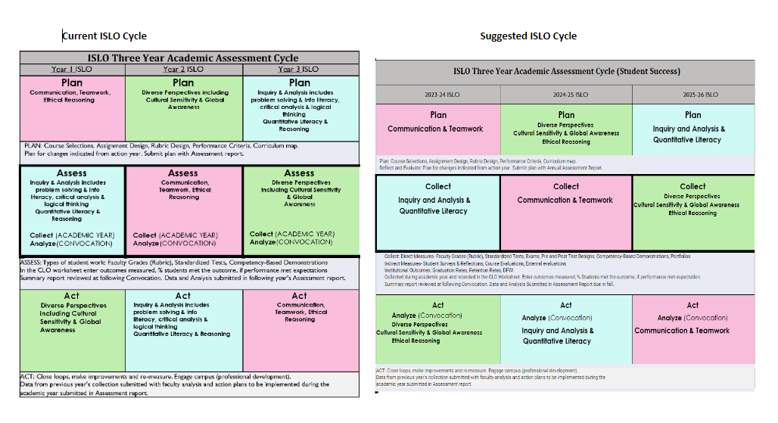
  - Assessment report templates were recommended to include pertinent details for requesting resources that would be used by Deans during the budget cycle. In light of meeting accreditation regulations: "1.D.4 The institution’s processes and methodologies for collecting and analyzing indicators of student achievement are transparent and are used to inform and implement strategies and allocate resources to mitigate perceived gaps in achievement and equity." & "1.C.7 The institution uses the results of its assessment efforts to inform academic and learning-support planning and practices to continuously improve student learning outcomes." On recommendation of the provost, a meeting with Dr. Alp has been scheduled for 5/24 to discuss the deans’ data needs for approving these requests. Below is a picture of the current template table.
    - This group recommended that these changes be made to the template for 2024-25 year’s report due Oct 2025 to give time to build and train. 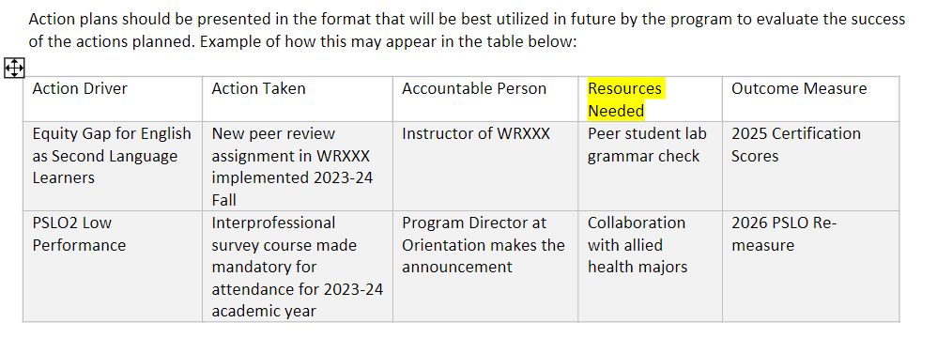
  - Assess report template may be a useful place to record department progress on Grant applications, research, publications and presentations. The provost was very positive on including this information in the report.
    - The group discussed that this kind of information may be more useful in program review rather than program assessment. Alternatively, if students are impacted by grants, workload, research and this information can be useful to provide a case for a resource request or and action plan then it should be included. An example table may be appended to the executive summary for addition to the 2024-25 academic year report.
    - Example from Environmental Studies Report here 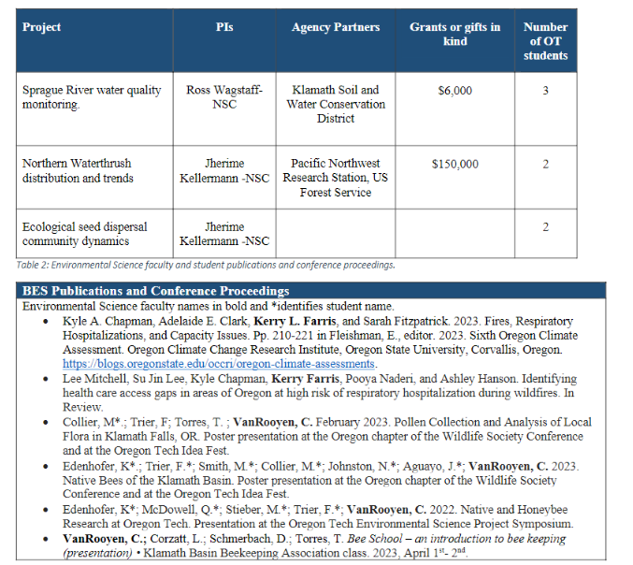

  - Dr. Afjeh was shown the Executive Summary questions and found them to be extremely helpful for the report he would be writing in 2026.
  - When posed the question on General Education Reform they said that a lot had to happen before reform could be looked at and that next year 2024-25 it would not be a priority. This group is encouraged to continue to collaborate with GEAC and to encourage assessment of General Education courses where possible.
- The CCC end of year report due at end of term. We need to document accomplishments, recommendations, and unfinished business in a bullet format. https://oregontech.sharepoint.com/:b:/s/AcademicAssessment2/Ed48y7D7s3ZCv-8Bo2WkN2MB6ZYIqaOVbb-6Pl3DiNoEbQ?e=5h40qA
  - Accomplishments: Trainings (individually documented) Template changes, Senior Exit Survey, Assessment Shell, Canvas Outcomes Build, Peer Review process, Grad program Assessed differently
  - Recommendations: Graduate program exit survey differences, and graduate program dashboard filter, Website Updates, hire an executive assistant for Office of Academic Excellence, provost charges Executive committee to assist with program review process
  - Unfinished: dashboard access via survey, Utilizing canvas tools to process assessment data, Continued collaboration with ISLO and GEAC to support foundational expectations.
- Goals for next year are difficult to come up with because we are waiting for the new AVPAE’s vision. Goals consist of continuing to provide trainings on the tools for assessment. Training at Convocation requested: 1-hour general session, 2 breakout sessions specific to Canvas Tools and the Template. Planning for these sessions to begin next meeting for finalizing on Monday 9/16 before CCT conference.
  - Suggested content of general session: NSSE results (received over summer) Awards, Summary data pulled from Assessment activities this year, Diversity presentation from faculty senate on equity gaps, Reminder of assessment resources and tools and dates/times of breakout sessions
  - Content for program coordinator training: best of examples
- Next meeting: Awards nominations, CCC report approval, Website improvement recommendations, NSSE information to look for or present, other?
- Action Items: Rachelle to send chairs the survey. Carrie to update the Program contacts list for 2024-25. Diedre Harlan to upload program assessment reports submitted this year to program websites. All to meet with Dr. Yu.

