Minutes 5/8/24
- Feedback from Program Coordinator’s Training – Christy shared out the feedback and questions from her discussion with faculty coordinating programmatic activities.
  - ISLO Rubrics on the website aren’t up to date with the ones being used in Canvas.
    - ETC committee to finish Teamwork and Communications next week then email or load to Teams file. https://oregontech.sharepoint.com/:f:/s/AcademicAssessment2/EsmthTAHRBZIk1t5VgtpIuABcQUrn6G7wPSrS-inVLFhQg?e=J4uq0W
    - QLIA to finish Inquiry and Analysis and Quantitative Literacy and email or load to the teams file.
    - Task: Rachelle to work with Dede Harlan to update downloadable rubrics on individual ISLO websites and ensure they are available in Canvas.
    - Charge for next academic year: ISLOs to update wording on ISLO websites.
  - Dashboard accessibility - Programs want people performing assessment work to be able to access programmatic material from dashboards. Christy developed survey to send to chairs this month requesting access for specific individuals to the program level data.
    - Presented survey tweaked to track incoming chairs and incoming program facilitators (person to be in the canvas shell) and to document dashboard access. Approved for send out by committee. Task: Christy to send out to chairs.
  - Dashboard usability – data in the dashboards needs to be current AND many programs need graduation data to be less than 6-years. DFWI data needs to be disaggregatable into separating Incompletes from Fails. Is this a training issue or a programming issue? Farooq to present at Convocation? Task: Begin planning convocation sessions
  - Basic Training Agenda: https://oregontech.sharepoint.com/:w:/s/AcademicAssessment2/EUl9VciPpepPiPHFHIO7WAEBDY61wVqKSmlfa98gMjKcrw?e=xvd7zK
- Questions for the Provost – Feedback suggested Assessment have a meeting with the provost and Dr Afjeh to ensure that templates for program assessment reports are capturing most useful data. Task: Rachelle and Christy to meet with provost and Dr. Afjeh this month.
  - Share template with provost with specific focus on resource allocation and executive summary. What information should programs have ready to justify positions or equipment requests. Link to process?
  - Update to Assessment cycle and Templates, does this need to be approved by Northwest or the Board or the Provost? Once approved, it should be posted on the webpage, annual report, canvas shell, and template.
    - Changes proposed – cycle verbiage, move Ethics to Diverse Perspectives
    - Undergraduate Template: https://oregontech.sharepoint.com/:w:/s/AcademicAssessment2/ERpCrqgLLaxIjlUByVFaP3ABrfp0dkMLFWL6ikKruTAyDQ?e=ETsbpO
    - Graduate Template: https://oregontech.sharepoint.com/:w:/s/AcademicAssessment2/EVNA-PDs75RHi0LjvARWC5oB6PUbFBKxVD3GfbYxkvZFng?e=vngxpj
- Questions for the AVPAE – coming in July, everyone available may meet with him.
  - Program Review – what are the plans? What data needs to be collected to prepare?
  - Convocation training – Gen session, new program facilitators session, time for programs to meet.
  - Gen Ed – 1) Definition of Gen Ed course. Resource from Krista Beaty What is General Education? Definition, Requirements & A List of Courses in 2024 | Research.com 2) How should Gen Ed be assessed? – Gen Ed “program report”, requirement for programs to have 4-year or less path to graduation curriculum map with ISLOs defined posted (may need to look for list of gen eds there) (could this be a workshop?) Task: Andie to meet with AVPAE over summer.
- As a group, we need to look over the Annual Report of Executive Committee due to the Provost at end of term. https://oregontech.sharepoint.com/:w:/s/AcademicAssessment2/EWuG6OJ_cUdFq9RW1r5E1c8B1j2JhKiIBdLQwVWzKeug6A?e=Mysb0j and the CCC end of year report due at the same time. https://oregontech.sharepoint.com/:b:/s/AcademicAssessment2/Ed48y7D7s3ZCv-8Bo2WkN2MB6ZYIqaOVbb-6Pl3DiNoEbQ?e=5h40qA
- Begin to think about goals and membership for next year. Task: Rachelle to follow up with members to ensure next year’s roster.

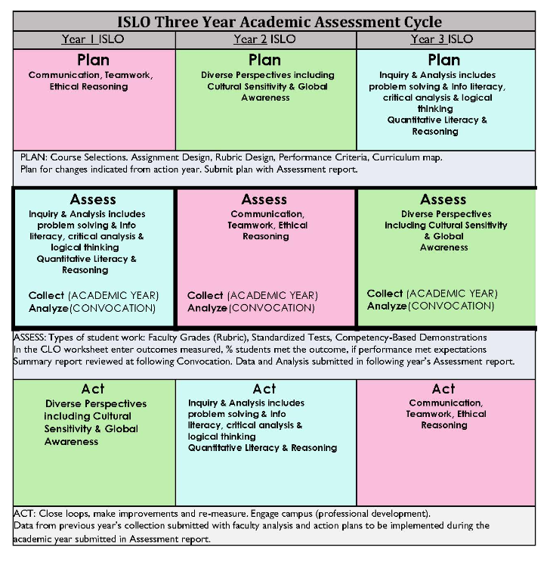
Current ISLO Cycle Suggested ISLO Cycle
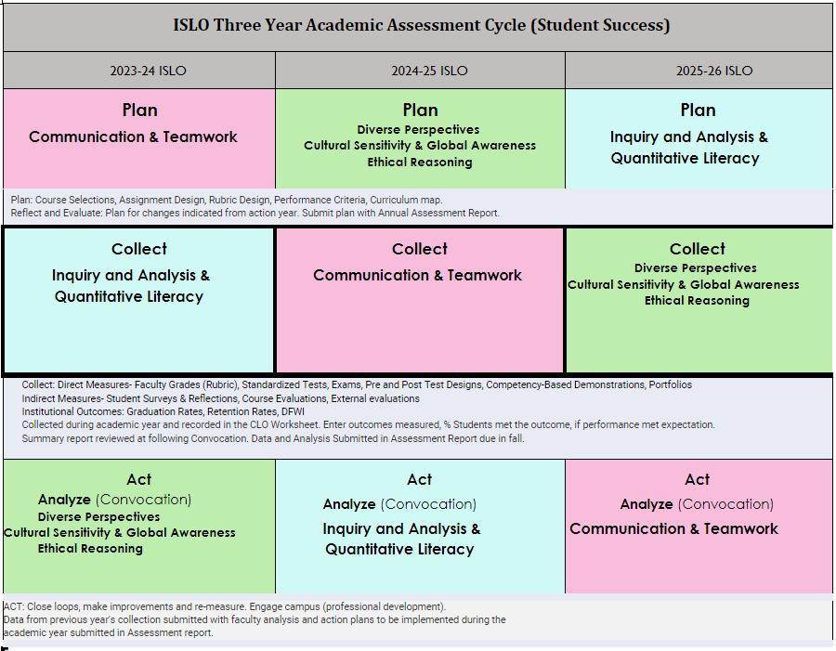
Current ISLO Cycle:

