Banner 9 Navigation
Desktop Reference Guide

Table of Contents
Introduction 3
What’s new with Banner Admin Pages? 3
Application Navigator – Welcome Page 4
Basic Navigation 5
Page Header 6
Key Block 6
Sections 7
Bottom Section Navigation 7
Backing out of Banner 8 Forms/Reports 7
Notification Center Messages 8
Data Display Options 9
Required Fields 9
Sort Order 9
Dates 9
Filtering 9
Filtering Data 10
Multiple Records 11
Advanced Features 12
Item Properties 12
Appendix 13
My Banner Personal Menu Setup 13
Banner “Buttons” Guide 14
Banner “Keyboard Shortcuts” Guide 15
Version Control 16

Introduction

Banner 9 is a major upgrade to the Banner System. According to Ellucian, “Banner 9 by Ellucian is no ordinary upgrade. It delivers a fresh user experience, all new tools, and significantly improved capabilities across Banner, driving new efficiencies so you can focus on student success.”
Banner 9 will provide a fresh look and updated functionality, including new functionality for faculty grading, student advising, and registration. Banner 9 replaces underlying Banner 8 technology that is being phased out, including Oracle Forms and Oracle Reports which impacts OIT’s customized Banner forms and reports. Customized forms and reports determined by our users to be critical to their business functions are being identified and will be converted to the Banner 9 format in the coming months.

Some of the new advantages include:
- Eliminating browser compatibility problems
- Ending dependency on Internet Explorer that allows for full browser support (IE, Chrome, Firefox, Safari; excluding Edge). During the initial rollout please continue using IE because Banner 8 form/reports will still be accessed in some instances.
- Greatly simplifying the upgrade process for administrators

What’s new with Banner Admin Pages?

- Application Navigator Welcome screen offers a “google like” experience for navigating throughout Banner Admin pages, offering multiple ways to search.
- Reorganization of the Banner Administrative menu.
- Banner Admin pages are transformed, web page-like versions of INB forms.

Application Navigator – Welcome Page

Application Navigator is the Welcome Page into Banner 9. The following information details functionality of Application Navigator.
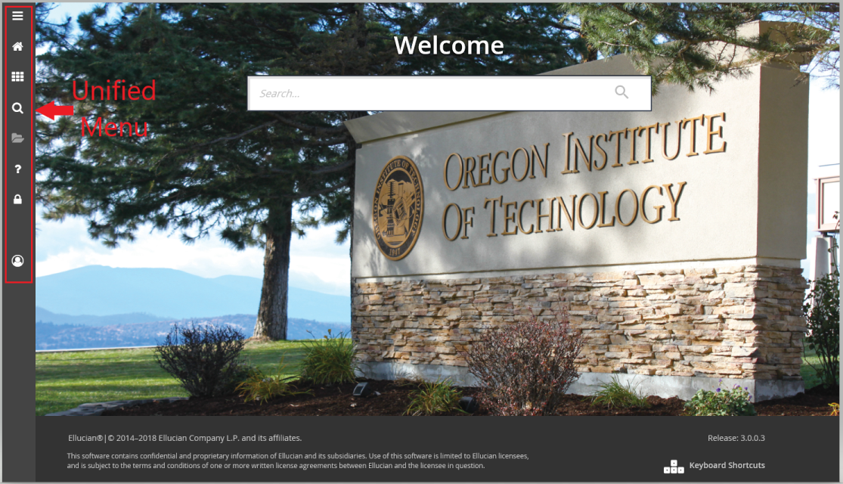
Use your OIT Single Sign On credentials to access the Banner 9 Welcome page. The Unified Menu is located on the left side of the page and is accessible from all pages within Banner 9. The Unified Menu icons provide the following functionality:
- Toggle Menu icon – The Toggle menu is identified with three horizontal lines. Click on this icon to expand the Unified Menu and include names of each icon.
- Dashboard icon (CTRL+Shift+X) – Clicking the Dashboard icon will bring the user back to Application Navigator (also known as the Welcome page, Landing page, Home page) from anywhere within Banner.
- Applications icon (CTRL+M) Click the Applications menu to bring up the Banner menu pages. Navigate through the sub menus until finding the page you are interested in opening. The My Banner option is also available from this icon and will allow users to create a personal list of pages that they use regularly. See the appendix for directions regarding how to set up My Banner.
- Search icon (CTRL+Shift+Y) – The Search icon is identified by the magnifying glass. Selecting this icon will open a Search window. Users can then enter either the descriptive name of the page or the Banner acronym for the page.
- Recently Opened icon (CTRL+Y) – The Recently Opened icon is identified with a picture of a folder. It is activated upon opening the first Banner page and then will show the number of recently opened pages. Open the list and select a page to access it.
- Help icon (CTRL+Shift+L) – The Help icon is identified by the magnifying glass. Selecting this icon from a Banner page will open a separate browser window with information pertaining to that page.
- Sign Out icon (CTRL+Shift+F) – The Sign Out icon is identified by the lock. It is important to remember to use the Sign Out icon when closing the application before closing the browser.
- Application Navigator has a set of keyboard shortcuts, which can be reviewed by clicking on Keyboard Shortcuts in the bottom right corner of the page. Please see the appendix for a full list of Keyboard Shortcuts.

Basic Navigation
The basic navigation of each Page (previously known as “Forms”) includes the page header, footer, key block, sections and tabs and the notification center.
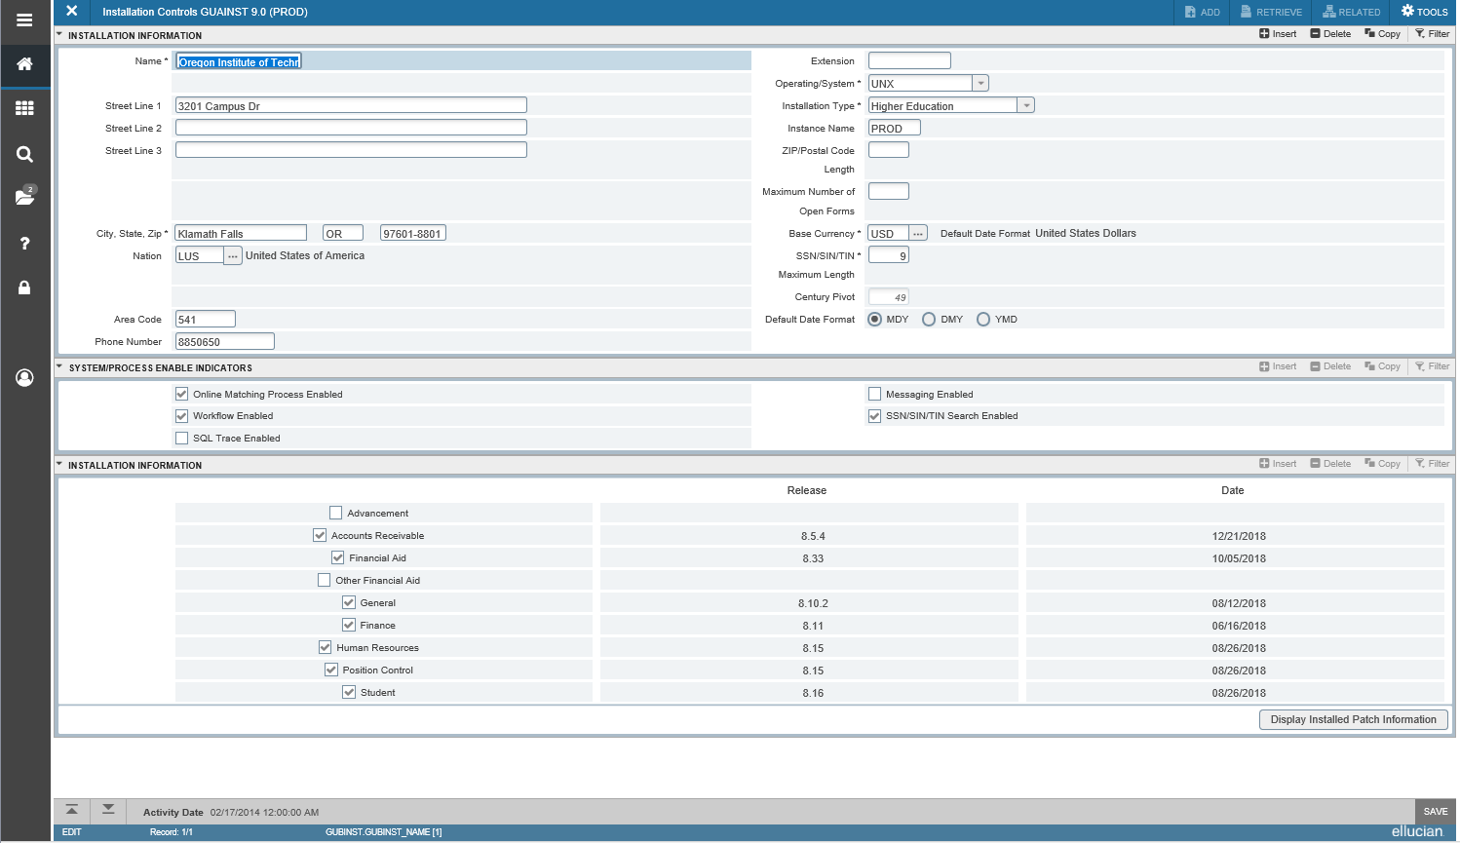

Page Header
The page header is part of the basic navigation and contains the following items:
- Page close icon “X” (CTRL + Q) – Always use this icon to close the page.
- Page title – Includes description, acronym, version, database and data refresh date (for non-prods).
- Add and Retrieve icons – These icons are not used by OIT; they are used with Banner’s Document Management (Xtender) system.
- Related Menu icon – Displays a list of pages that are related and can be accessed from this page.
- Tools Menu – Will include refresh, export, print, clear record, clear data, item properties, display ID image, and other options controlled by the page.
- Notification Center – Will be located to the right of the Tools Menu and will display the following information as needed: successful save of data, warning messages, error messages, informational messages, active message count. Users can click number in the box of the page header to open or close the Notification Center.

Key Block
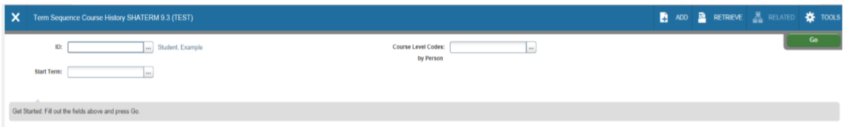
The first block on most pages contains key information. Consistent with Banner 8, the key block determines what data is entered or displayed on the rest of the page. All the information on the page is related to the key block. The key block stays on the page as subsequent sections are displayed.
When the cursor is in the key block, the fields that can be entered in the key block are enabled. When leaving the key block, the fields in the key block are disabled.
When the cursor is in the key block, the information is displayed in a column format. When leaving the key block by clicking the Go button (previously Next Block), the data is rearranged into a linear format and not enterable.
To access the body of the page, populate the key block data and then click Go.
Users can return to the key block when in the body of a page by clicking Start Over (previously Rollback).

Sections
Pages are divided into Sections (previously known as Blocks) that contain additional details for the key information. A section can represent one record or multiple records depending on the type of information being worked on. Each section contains related information.
Sections of data are accessed by scrolling up and down the page. They can be opened or collapsed by clicking on the arrow on the far left side of the section header. Some sections are accessed by using tabs that group information in a meaningful way.
If available, the sections can have a header that includes icons for the following actions:
- Insert – Use this to insert records in the section.
- Delete – Use this to delete records in the section.
- Copy – Use this to copy records in the section.
- More Information – This icon will only appear if supplemental data can be entered for the record. The icon is displayed with a check mark if supplemental data already exists for the record.
- Filter – Use this to filter records in the section.

Bottom Section Navigation
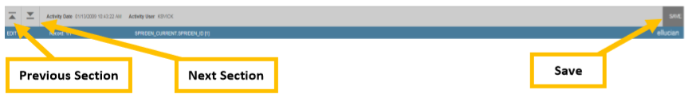
The bottom section of the page will contain icons to be used for navigation, perform functions and display additional information.
- Previous Section – Will take user backwards in the sections (Alt+ Page Up).
- Next Section – Will take user to the next section of the page (Alt+ Page Down).
- Activity Date – This is the current system time stamped for the record when it was created or last modified.
- Activity User – Name of account user creating or modifying the record.
- Save – This button is used to save data.

Backing out of Banner 8 Forms/Reports
This is a temporary instruction while the AppDev team completes the transition of all Banner 8 customized forms and reports to Banner 9. The first time a user accesses an OIT customized form or report that has not been transitioned to Banner 9, the Oracle Forms Services (Java) is invoked to support the Banner 8 form. When work is complete within the Banner 8 form, close the form by clicking on the “X”, then click the Dashboard icon in the Unified menu to return to the Banner 9 Welcome screen. It is important that all navigation in Banner 9 starts from Application Navigator (Welcome screen).

Notification Center Messages
There are three different types of message notifications when working in Banner 9 along with a yellow box that notes the amount of messages:

- Error Notification – Messages appear in ‘red’ and are a hard stop. Corrective action is required.
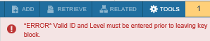

- Warning Notification – Messages appear in ‘yellow’ and may ask for acknowledgement to continue.
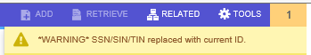
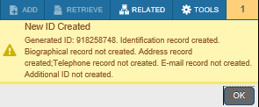

- Success Notification – Will display a checkmark in a circle when message is displayed.
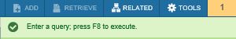
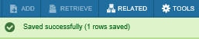

Data Display Options

Required Fields
An asterisk (*) displayed next to a field name indicates that the field requires a value before continuing on the page. The system uses the definition of the field as it is used in the application to determine if it is required. For fields that have conditional logic that determines whether they are required, the asterisk (*) is not displayed. If the user leaves a section or a page without entering information in a required field, the page notifies the individual in the Notification Center, requiring the user to perform some additional action.

Sort Order
In a grid layout, values for a field can be sorted and, if the user has chosen to sort the data, an up or down arrow next to the field name indicates the current sort order for the field. The user can click the field label to reverse the sort order.

Dates
Enter the date directly or use the calendar icon for date selection. The date format is mmddyyyy. To enter the current date, type any letter and [TAB].

Filtering
The Filtering feature allows the user to quickly find a value for a field. The Filter option next to a field is displayed as “…” indicating that the field has the Lookup feature. There are two options for filtering data:
Basic Filtering
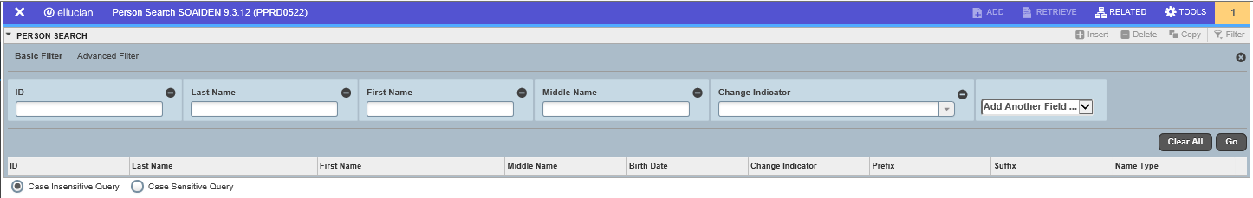
Advanced Filtering:
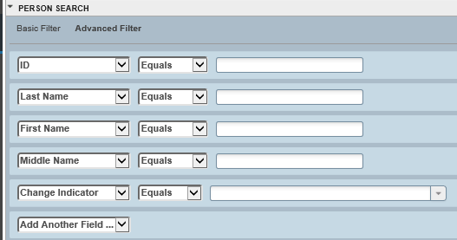

Filtering Data
Users can also filter data in a section if there is an active Filter icon in the section header (upper right corner).
Use the following steps to filter data:
- Click the active Filter icon or “…” for the section or key block.

- Select Basic or Advanced filter options

- The Advanced option appears as following. Fill in the fields as needed or add another field. Select filtering criteria, such as Equals, Starts With, etc.,
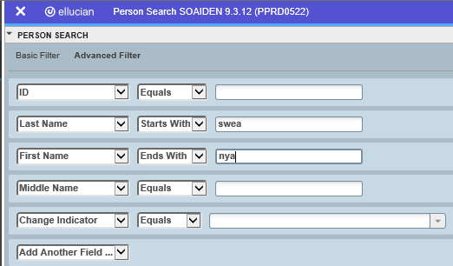
Entered data persists if filter option is changed back to Basic as shown below:
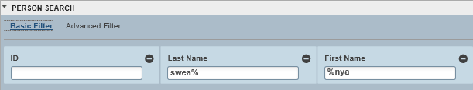

- Optional: To add another field to the filter criteria, choose a field from the Add Another Field dropdown, and repeat previous steps. Repeat this until all filter criteria are entered.

- When all filter criteria is entered, click Go (F8) to display the filter results. The number of records retrieved is displayed at the bottom of the section. The results for a field can be sorted in ascending or descending order by clicking on the field label in the column header. Sort order can be reversed by clicking the field label.

- Select the data from the list of returned records or can filter again. Cancel to get out of filtering.

Multiple Records

Data can exist in multiple records of the same type in the database, for example addresses, and are displayed in multiple ways. Records can be viewed one record at a time or in a grid.
One Record at a Time: In this instance, the details of the data are not displayed in a table grid, but rather in a more easily readable manner. Users can move from record to record using pagination controls (the arrows located in the bottom left hand corner).

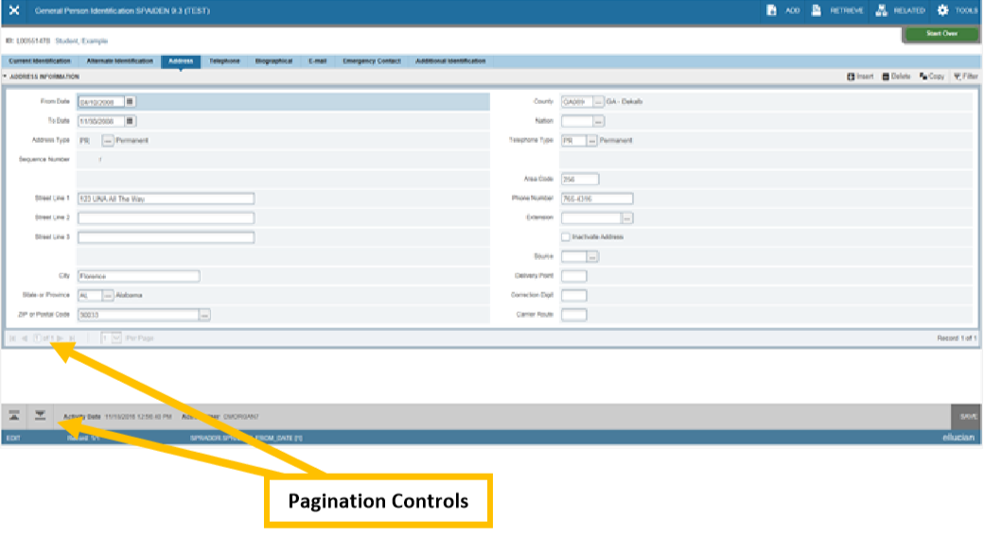

In a Grid: In this instance, the data is presented in column and row format. Users may need to scroll to view all the data. Users can page through the records using the Pagination Controls, decide how many records to review in the grid, and sort the data in ascending or descending order by clicking on the arrows next to the column heading.
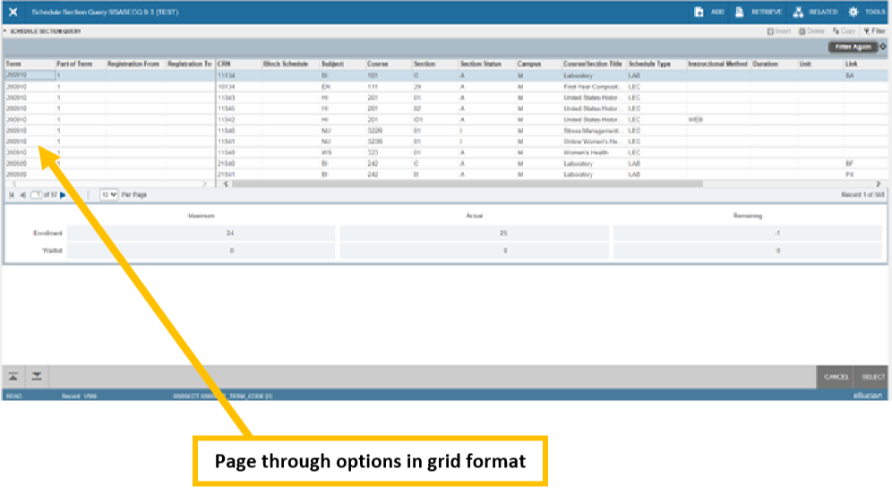

Advanced Features

Item Properties

Item Properties lists all properties for the column/field where the cursor is currently located.
Item properties include the column’s internal database name, whether the column is required, type of data (character or numeric), maximum length, and other characteristics of the field. The specific properties that are displayed depend on the type of field. To display Item Properties for a field, place the cursor in the field and select Tools > Item Properties.

Appendix

My Banner Personal Menu Setup

Users can create a personal menu tied to your Banner user ID. Your personal menu will contain the pages, jobs, menus, and Quick flows that are most important in your daily work. Once the personal menu is created, you may access it from the Applications menu.

- From the Welcome page, use either the search box in the middle of the screen or the search icon to enter either “My Banner” or “GUAPMNU”.

- The My Banner Maintenance page contains:
  - Type: A drop down menu located the top of the screen to allow you to choose from Oracle Forms, Job Submissions, Menus, Menu Messages, and Workflows to access all forms needed to customize your My Banner.
  - Object Type: All available pages, jobs, menus, or quick flows associated with the chosen type selected from the drop down menu.
  - Buttons: Buttons are used to insert or remove selections from the available list to your My Banner list.
  - Object Selection: Will display the contents of your personal menu.

- To add objects to your personal menu, select the name from the left pane by double clicking it and then use the Insert buttons in the middle of screen to add to the right pane.

- After each page selection to the right pane, select Save in the bottom right hand corner to retain selections.

- Shortcut to creating your My Banner list: Beginning with the Object Selection panel (the right panel), select the first open record. This is displayed as a box with a cursor available. Enter the seven character page and arrow down to create the next record. Users may enter as many pages as they wish. Remember to select Save before exiting the page.

- Users will have to sign out and sign back in to see changes on your My Banner.

Banner “Buttons” Guide

Button | Description
Add and Retrieve | The Add and Retrieve are not used by OIT; they are used with Banner’s Document Management (Xtender) system.
Go | Use the Go button to advance to the body of the page after populating the key block.
Save | Use the Save button to save changes on the page. The Save button is located on the bottom right side of the page.
Section Navigation | Use the Next Section button to navigate to the next section of data. Use the Previous Section button to navigate to the previous section of data. The Next Section and Previous Section buttons are located at the bottom left of each page.
Select and Cancel | Use the Select button to select and retrieve data from a called page to the current page. Use the Cancel button to return to the called page without retrieving any data. When going to a secondary or called page to retrieve data, the Select and Cancel are presented at the bottom right of the page.
Start Over | Use the Start Over button to return to the key block of the page.

Banner “Keyboard Shortcuts” Guide
 | Action | Banner 9 | Banner 8 - Cloud
 | Application Navigator: |  | Banner 9 keyboard shortcuts will work in Banner 8 if you are running Banner 8 with Application Navigator and have applied the keyboard shortcut configuration setting
1 | Access Menu | Ctrl+M
2 | Display recently opened items | Ctrl+Y
3 | Search | Ctrl+Shift+Y
4 | Sign out | Ctrl+Shift+F
5 | Help | Cntl+Shift+L
6 | Cancel Pages, Close Current Page or Cancel Search/Query (in Query mode) | Ctrl+Q | Ctrl+Q
7 | Choose/Submit | Enter | Enter
8 | Clear All in Section | Shift+F5 | Shift+F5
9 | Clear One Record | Shift+F4 | Shift+F4
10 | Clear Page or Start Over | Shift+F7 | Shift+F7
11 | Count Query | Shift+F2 | Shift+F2
12 | Delete Record | Shift+F6 | Shift+F6
13 | Down/Next Record | Down Arrow | Down Arrow
14 | Duplicate Item | F3 | F3
15 | Duplicate Selected Record | F4 | F4
16 | Edit | Ctrl+E | Ctrl+E
17 | Execute Filter Query | F8 | F8
18 | Exit | Ctrl+Q | Ctrl+Q
19 | Expand/Collapse Drop-Down Field | Alt+Down Arrow | Click Field
20 | Export | Shift+F1 | Extract data with Key or  Extract Data no Key
21 | First Record or List | Ctrl+Home
22 | Insert/Create Record | F6 | F6
23 | Last Page | Ctrl+End
24 | List of Values for Field | F9 | F9
25 | More Information | Alt+Shift+U | Alt-H
26 | Next field or Item | Tab | Tab
27 | Next Page Down | Page Down | Page Down
28 | Next Tab or Page | Alt+Page Down | Ctrl+Page Down
29 | Open Menu Directly | Ctrl+M | F5
30 | Open Related Menu | Alt+Shift+R
31 | Open Tools Menu | Alt+Shift+T
32 | Page Tab 1,  Page Tab 2, and so on . . . | Ctrl+Shift+1  Ctrl+Shift+2 (and so on)
33 | Previous Field or Item | Shift+Tab | Shift+Tab
34 | Previous Page Up | Page Up | Page Up
35 | Previous Tab or Page | Alt+Page Up | Ctrl+Page Up
36 | Print | Ctrl+P | Shift+F8
37 | Refresh or Rollback | F5 | Shift+F7
38 | Save | F10 | F10
39 | Search or Open Filter Query | F7 | F7
40 | Select on a Called Page | Alt+S | Shift+F3
41 | Toggle Multi/Single Records View | Ctrl+G
42 | Up/Previous Record | Up Arrow | Up Arrow
Note: this information is also available on the bottom right of Banner 9 Welcome Page

Version Control
Date | Description | Author | Version
8-24-18 | Initial document | T.Sweaney | 1.00
1-3-19 | Finalized document | T.Sweaney | 1.01

Note: This is a living document and will be updated as deemed necessary. Please send corrections or suggested content to “ITS-AppDev@oit.edu”.

